Devyn Mustard

10/15/2023

7-1 Project Reflection

Proposal:



Final: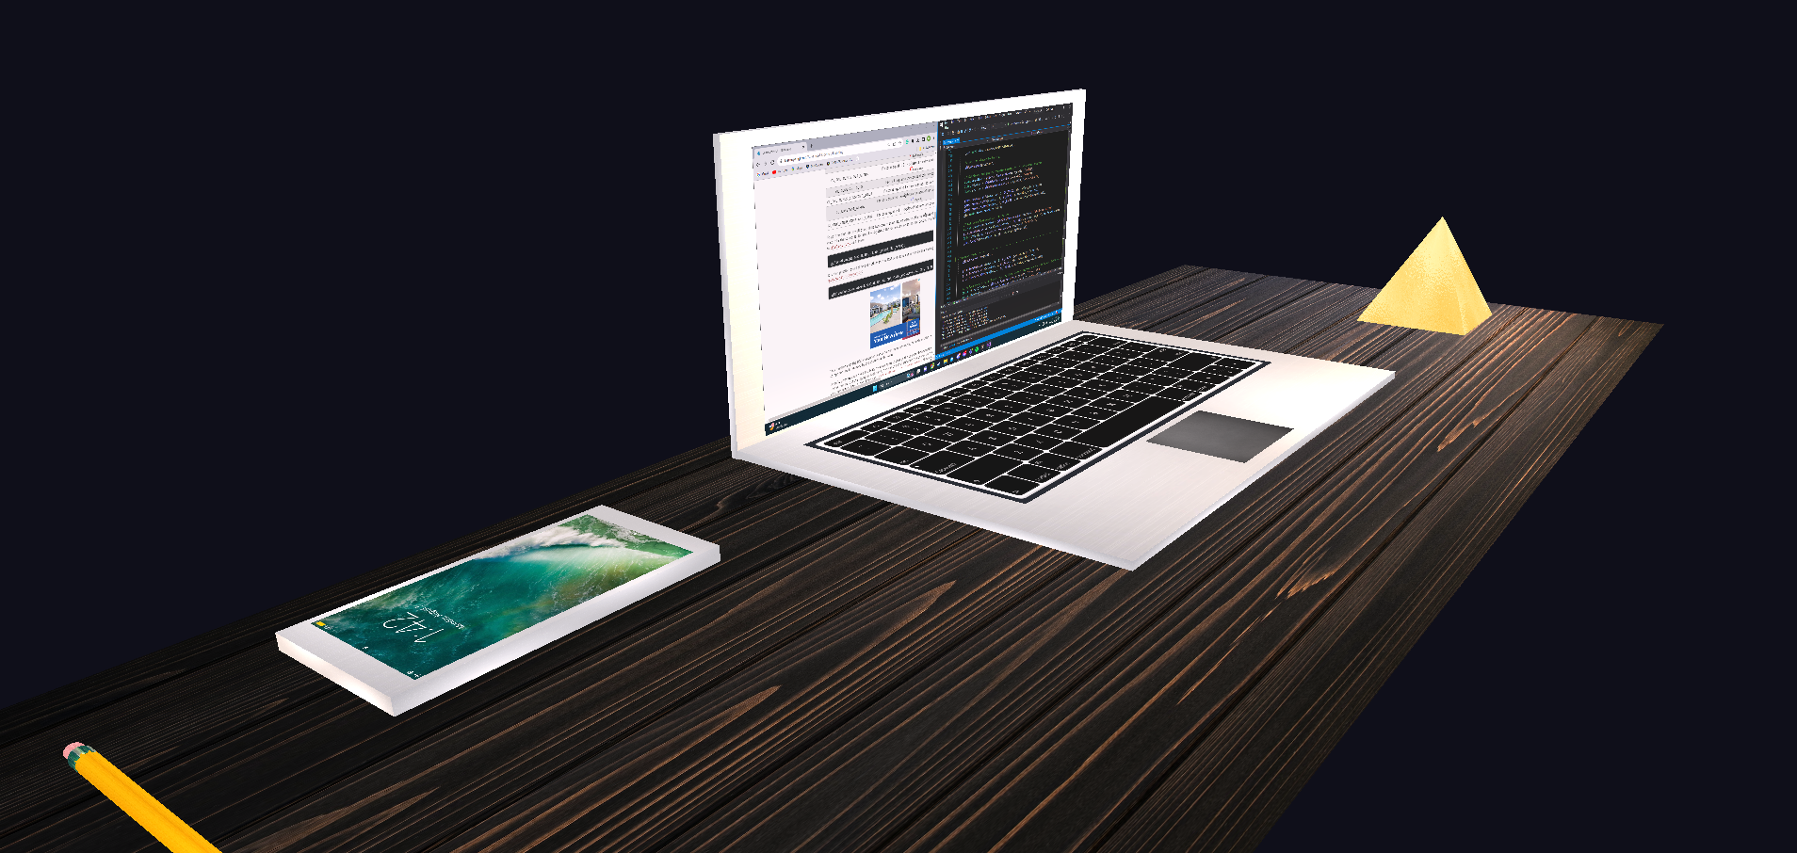

Recreating the modern desk scene took several redesigns and iterations to get to the results that were achieved. Many of the objects from the original photo did not seem to fit the overall feel of the scene. Wanting to take the design and approach to a more modern look, design changes had to be made. The laptop remained the same, constructed of two rectangles, and three planes. The two rectangles are both the base and top half of the object, while the three planes make up the laptop’s screen, keyboard, and trackpad. The pencil in the scene was made up out of 3 cylinders, one cylinder was the main pencil object, another was the metal holder of the eraser, and the final one was the eraser itself. The phone was simply constructed out of a small rectangle and a plane that represents the screen. The lamp object is a pyramid mesh, emitting a soft warm yellow light. All of these objects are resting on a flat plane. Above all objects, rests a cold white ambient light, ensuring all objects have light emitted on them. Staying faithful to the original image, I branched off and took the modern approach. Mixing both a warm and cold white light results in a more cohesive scene, thanks to the shaders that were written.

You are able to navigate through the scene utilizing mouse and keyboard movement. The keys WASD QE control the camera's direct movement, W = FORWARDS, A = LEFT, S = BACKWARDS, D = RIGHT, Q = UP, E = DOWN. The key P changes the camera’s view perspective back and forth from perspective to orthographic. The mouse input is used to control the pitch and yaw that the camera is looking at. With all of these functions combined, you are able to easily transverse and see all aspects of the 3D scene.

The program has multiple functions that allow for modularized OOP code. Splitting the source code into multiple files helps keep the code easy to read and follow along. Keeping vertices data in different variables and assigning them to an array of a VAO and VBO allows for fewer declarations and utilizes less memory. Creating a cylinder generation function allows for cylinders to be easily created with a specified amount of triangles, length, and width. This function can be called and automatically assigns and binds the vertex data to VAO VBO. This results in much less code, as it is written once and can be reused any amount of times.